**Assembly instruction for CPAP device**

**System Diagram**

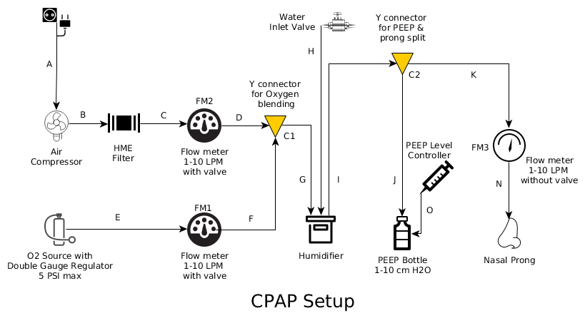

BOM link: <https://docs.google.com/spreadsheets/d/1dIW1Tr6NzaFTdaCL5RmxEFb9l5C3onxBBb0UbcO2Jm4/edit#gid=0>

Step 1.1 Prepare the cut outs in the main enclosure

|  |  |  |
| --- | --- | --- |
| **Step** | **Instruction** | **Image** |
| 1.0 | Make a 40mm X 50mm clearance for cable inlet at any of the side walls of the enclosure. | Fig.0 |
|  | Note the type of the flowmeter. make two pairs of 15mm holes 70mm apart for fitting in the flowmeter. | Fig.1 |
| 1.2 | Place it as shown (FM1, FM2) | Fig.2 |
| 1.3 | Fix the screws on the enclosure front plate to keep the final output flowmeter in place. (FM3) | Fig.3 |
| 1.4 | Cut two pair of PVC tubes for each flowmeter & connect the elbow connectors to the tubes as shown in the picture.  C-FM2, D-FM2 tubes and  E-FM1, F-FM1 tubes assembly.  L-Connectors (BOM, sl. no. 2) | Fig.4 |
| 1.5 | Connect the tubes to the flowmeter. The outputs of both air & oxygen carrying flowmeters are connected through a Y connector (C1).  D-C1 and F-C1 branch, where the other ends of D & F are connected to the FM2 & FM1 outlet .  C is connected between FM2 inlet & Air compressor (HME filter is optional)  E is connected between O2 valve and FM1 inlet | Fig.5 |
| 1.6 | Drill two holes of 5mm dia & 65mm apart and fix the bottle holder in that location. | Fig.6 |
| 1.7 | Prepare the PEEP bottle assembly  Branches shown: I, C2, J, K | Fig.7 |
|  | PEEP bottle to be mounted as shown. | Fig.8 |
|  | Prepare the base-plate for compressor mounting.  Placement of the holes may differ depending on their actual mounting arrangement | Fig.9 |
| 1.8 | Assemble the pump & place it in the mounting holes.  Make 4 mounting holes for placing the baseplate inside the enclosure. Dimension: 190mm X 90mm | Fig.10 |
|  | Connect the compressor outlet to the flowmeter inlet as shown.  The outlet of the flowmeter to be connected to the inlet of the humidifier.  Air compressor outlet is directly connected to FM2 inlet via branch C (HME filter & branch B is optional & omitted) | Fig.11 |
| 1.9 | Preparation of the Humidifier  Drill three holes of 12mm dia & 50mm apart and place the threaded elbow connector as shown in the image.  Inlet and outlet port of the humidifier & water filling connector.  Some masking tape/ glue gun can be applied for achieving better grip & air-tightness.  Parts: Humidifier & connectors for branches G, H, I.  Threaded straight connectors.  (BOM sl. no. 7) | Fig.12    Fig.13 |
| 1.10 | A ball valve is set at the top of the system to fill water in the humidifier.  Place the humidifier chamber in the appropriate place. | Fig.14 |
| 1.11 | The final placement of compressor & humidifier | Fig.15 |
| 1.12 | Drill a hole of 12mm diameter at the center of the cap of the bottle & place the threaded connector & 180mm PVC pipe of 12mm internal diameter.  Drill 4 holes of 5mm diameter at the cap of the bottle to insert luer lock tubing. This tube will be connected to a 60ml or 100ml syringe for adding or reducing water to the PEEP bottle. | Fig.16 |
| 1.13 | Cut a 115mm tube & place it in between the humidifier chamber outlet & Y connector.  Connect the nasal cannula & tubing to the wye connector. | Fig.17 |
| 1.14 | Assembled bubble CPAP | Fig.18 |